CO 3 AT 2
CASE STUDY

NAME: S.SRI MATHI
REG.NO: 192424095
COURSE CODE: CSA0603
COURSE NAME: DESIGN AND ANALYSIS OF ALGORITHM
DATE: 05.08.2026

1.INTRODUCTION
Financial institutions such as banks, payment gateways, insurance companies, and stock markets process thousands of transactions every second. These transactions include deposits, withdrawals, online payments, fund transfers, and purchases. Before generating reports, calculating balances, detecting fraud, or performing financial analysis, transaction records must be sorted efficiently.
If sorting takes too much time or memory, report generation becomes slower, affecting decision-making and customer service. Therefore, selecting an efficient sorting algorithm is important for improving the overall performance of financial data processing systems.

2. PROBLEM STATEMENT
Develop a financial transaction processing system that sorts transaction records based on transaction amount. Implement both Merge Sort and Quick Sort using the Divide and Conquer technique. Compare the algorithms in terms of execution speed, stability, memory usage, and time complexity. Based on the comparison, determine the most suitable algorithm for processing financial transaction data.

3. ALGORITHM USED
This case study uses the Divide and Conquer strategy.

Merge Sort
Merge Sort divides the transaction list into smaller sublists until each sublist contains only one element. It then merges the sublists in sorted order to produce the final sorted transaction list.

Quick Sort
Quick Sort selects a pivot element and partitions the transactions into two groups: elements smaller than the pivot and elements larger than the pivot. The same process is recursively applied until the entire list is sorted.

4. JUSTIFICATION FOR CHOOSING THE ALGORITHM
Merge Sort and Quick Sort are selected because they are among the most efficient comparison-based sorting algorithms for large datasets.
Merge Sort guarantees O(n log n) time complexity in all cases and preserves the relative order of equal elements, making it a stable sorting algorithm. This property is useful in financial applications where multiple transactions may have the same amount but should remain in chronological order.
Quick Sort is widely used because of its excellent average-case performance and low memory consumption. It performs sorting in-place and is generally faster than Merge Sort for most practical applications when an appropriate pivot is selected.
Both algorithms apply the Divide and Conquer technique, making them suitable for processing large volumes of financial transaction records efficiently.

5. COMPLEXITY ANALYSIS

Analysis
- Merge Sort provides consistent performance regardless of input order.
- Quick Sort performs faster in most average situations but can degrade to O(n²) when poor pivot selection occurs.
- Merge Sort requires additional memory for merging.
Algorithm | Best Case | Average Case | Worst Case | Space Complexity
Merge Sort | O(n log n) | O(n log n) | O(n log n) | O(n)
Quick Sort | O(n log n) | O(n log n) | O(n²) | O(log n)
- Quick Sort requires very little extra memory because sorting is performed in-place.

6. MANUAL EXECUTION (STEP-BY-STEP PROCESS)

Sample Transaction Amounts
4500
1200
9800
3500
6700
1500

Merge Sort

Step 1
4500 1200 9800 3500 6700 1500
Split into two halves
4500 1200 9800

3500 6700 1500

Step 2
Further divide
4500

1200 9800

3500

6700 1500

Step 3
Divide again
4500

1200

9800

3500

6700

1500

Step 4
Merge in sorted order
1200 9800

1500 6700

Step 5
Merge larger groups
1200 4500 9800

1500 3500 6700

Step 6
Final Merge
1200 1500 3500 4500 6700 9800

Quick Sort
Initial List
4500 1200 9800 3500 6700 1500
Choose Pivot
4500
Partition
Left
1200 3500 1500
Pivot
4500
Right
9800 6700
Sort Left
1200 1500 3500
Sort Right
6700 9800
Final Result
1200 1500 3500 4500 6700 9800

7. APPLICATIONS
Merge Sort and Quick Sort are widely used in real-world financial systems.
- Banking transaction processing
- Online payment systems
- Credit and debit card transaction analysis
- Stock market trading platforms
- Financial report generation
- Tax and audit record processing
- Insurance claim processing
- Digital wallet transaction management
- Fraud detection systems
- Financial data analytics
8. ADVANTAGES
Merge Sort | Quick Sort
Guaranteed O(n log n) performance. | Excellent average-case performance.
Stable sorting algorithm. | Faster than many sorting algorithms in practice.
Suitable for large datasets. | Requires very little additional memory.
Efficient for linked lists. | Performs sorting in-place.
Ideal for external sorting where data is stored on disk. | Efficient for large datasets stored in memory.

9. LIMITATIONS
Merge Sort | Quick Sort
Requires additional memory during merging. | Worst-case complexity is O(n²).
Slightly slower than Quick Sort for smaller datasets. | Performance depends on pivot selection.
More memory-intensive. | Not a stable sorting algorithm.
Efficient for linked lists. | Performs sorting in-place.
Ideal for external sorting where data is stored on disk. | Efficient for large datasets stored in memory.

10. Comparison with Other Algorithms
Feature | Bubble Sort | Selection Sort | Insertion Sort | Merge Sort | Quick Sort
Technique | Comparison | Comparison | Comparison | Divide & Conquer | Divide & Conquer
Best Case | O(n) | O(n²) | O(n) | O(n log n) | O(n log n)
Average Case | O(n²) | O(n²) | O(n²) | O(n log n) | O(n log n)
Worst Case | O(n²) | O(n²) | O(n²) | O(n log n) | O(n²)
Stable | Yes | No | Yes | Yes | No
Extra Memory | No | No | No | Yes | No
Suitable for Large Data | No | No | No | Yes | Yes

11. SCREENSHOT OF THE PROGRAM
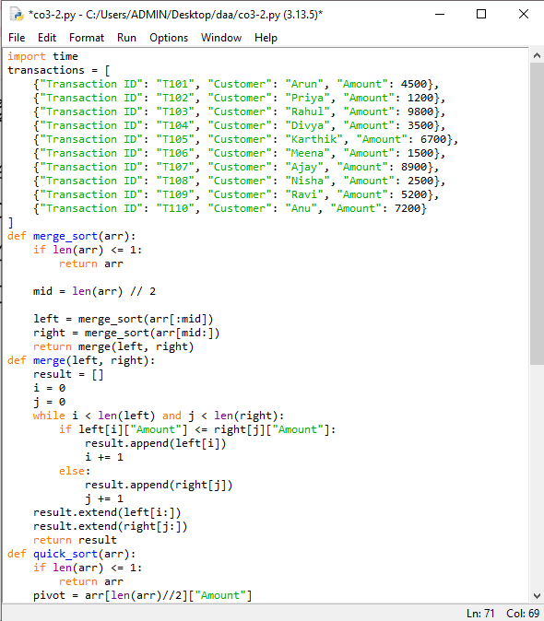
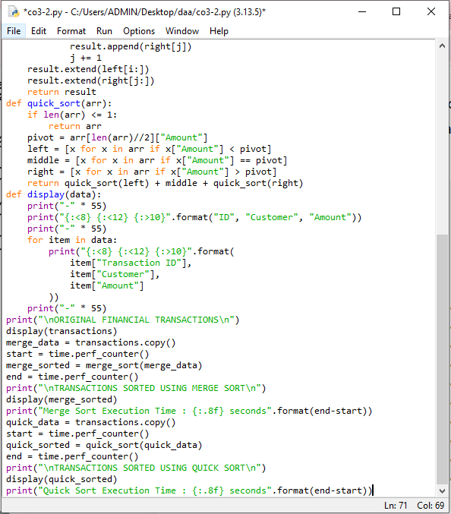

12. OUTPUT SCREENSHOT

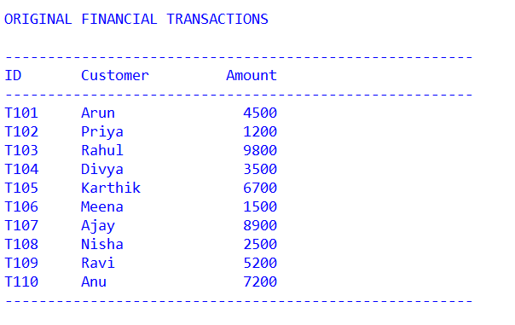
A) Original transaction data

B) Sorted output using Merge Sort

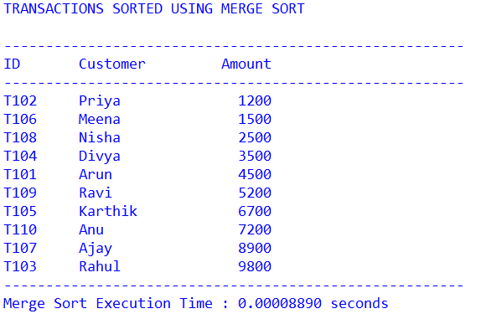

C) Sorted output using Quick Sort

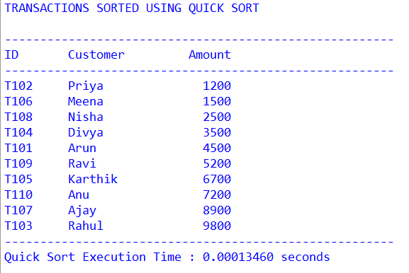

13. CONCLUSION
Financial systems require efficient sorting algorithms to process large numbers of transaction records quickly and accurately. Merge Sort provides guaranteed O(n log n) performance and maintains stability, making it suitable when preserving the order of equal transactions is important. Quick Sort offers superior average-case performance with lower memory usage, making it ideal for high-speed in-memory processing.
For financial systems where transaction order must be preserved, Merge Sort is the preferred choice because of its stability and consistent performance. For applications that prioritize execution speed and memory efficiency, Quick Sort is more suitable when an effective pivot selection strategy is used.

